Draft JMJP 27.05.2018

Reaching the Top ...

A guide to completing the Chief Scout’s Platinum, Diamond & Queen’s Scout Awards with 1st Claygate Scout Group

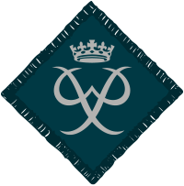
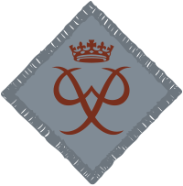
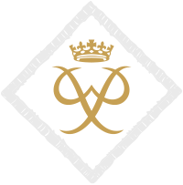

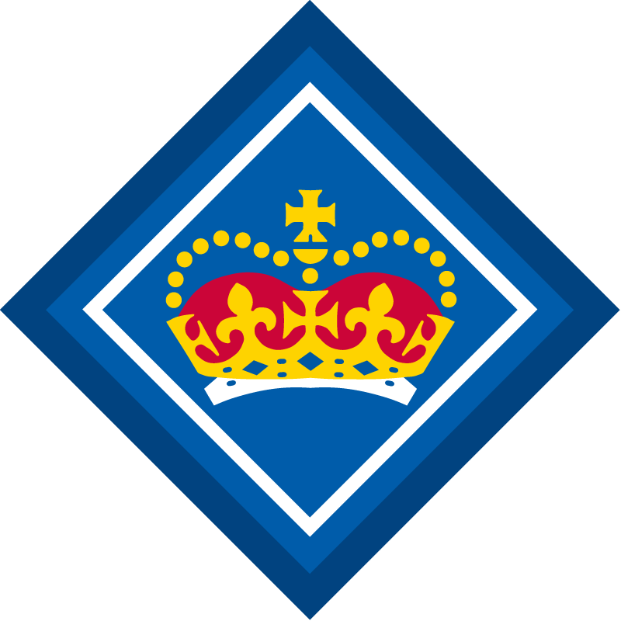

There are six awards available to Explorer Scout and Network sections:

 | Scouting | DofE | When start?
 | Chief Scout’s Diamond Award | Bronze Duke of Edinburgh Award | Age 14 or older
 | Chief Scout’s Platinum Award | Silver Duke of Edinburgh Award | Age 15 or older
 | Queen’s Scout Award | Gold Duke of Edinburgh Award | Age 16 or older

These awards are not based on competition but instead focus on teamwork, commitment and determination.

Completion of a DofE award counts towards the requirements for achieving the associated scouting award and therefore members can achieve two significant awards at each level.

The awards can take between 6 - 18 months to complete depending on the level of the award.

What’s involved?

For all awards:

Skill A hobby or activity such as web design, learning to drive, learning to cook or playing in a band, that you should show progress and lasting interest. The skill can be existing or something new. The DofE Leaders can provide a long list of possible options and advice on what might be appropriate. A skill can’t also be a sport, see below.

Volunteering Providing a service to a group or community, you should have briefing and training to gain the necessary skills. Volunteering can include being a Young Leader with 1st Claygate.

Physical Recreation Completing an agreed programme of taking part and achievement in a sport.

Expedition Explore the outdoors on foot, dinghy, canoe, boat or cycle, over a set number of days and night. At 1st Claygate participants will do their Bronze and Silver expeditions with the Group, but be sent to a specialist operator for the Gold Expedition in wild country.

Additionally for Gold DofE and the QSA:

Residential For Gold Duke of Edinburgh's award and Queen's Scout award ONLY, a trip in a setting away from home with people who you do not know.

Additionally for the scouting awards:

International, Community and Values List The Scouting awards require you to complete two items from this list at each award level.

Nights Away Experiences The Scouting awards require you to complete a certain amount of nights away for each level of the award.

Chief Scout’s Platinum Award and DofE Bronze Award

Age you can begin the Awards: 14 years old

Minimum time Span: 6 months

Registration Process:
(i) DofE Bronze - 1st Claygate DofE Leaders Jonathan Perkins and Sally Shortman
(ii) Chief Scout’s Platinum Award - Explorer Leader

Bronze Duke Of Edinburgh Award/ Chief Scout's Platinum
Volunteering | Physical | Skill | Expedition
3 months | 3 months | 3 months | 2 Day 1 Night
You must undertake a further 3 months in either Skill, Physical or Volunteering

Chief Scout's Platinum Award (Additional Requirements)

1. Be a member of Explorer Scouts or the Scout Network for at least 6 months

2. Complete 6 nights away as an Explorer Scout or member of the Scout Network, of which 4 must be camping

3. Complete two activities from the International, Community and Values List, the two activities should come from different areas.

Chief Scout's Diamond and Duke of Edinburgh Silver Award

Age you can begin the Awards: 15 years old

Minimum time Span:
6 months as an entrant who has completed their Bronze Duke of Edinburgh
12 Months as a direct entrant

Registration Process:
(i) DofE - 1st Claygate DofE Leaders Jonathan Perkins and Sally Shortman
(ii) Chief Scout’s Diamond Award - Explorer Leader

Silver Duke Of Edinburgh Award/ Chief Scout's Diamond
Volunteering | Physical | Skill | Expedition
6 months | One section for 6 months and one section for 3 months |  | 3 Day 2 Nights
Direct entrants must undertake an extra 6 months in the Volunteering or the longer of the Physical or Skill section

Chief Scout's Diamond Award (Additional Requirements)

1. Be a member of Explorer Scouts or the Scout Network for at least 12 months, this can include time counted for the Chief Scout's Platinum Award

2. Complete 12 Nights away as an Explorer Scout or member of the Scout Network, of which 8 must be camping, this can include time counted for the Chief Scout's Platinum Award

3. Complete two activities from the International, Community and Values List, the two activities should come from different areas and should not be the same as the ones completed for the Chief Scout's Platinum Award

Queen’s Scout Award and the Duke of Edinburgh Gold Award

Age you can begin the Awards: 16 years old
[NB: must be completed by the time the participant is 25]

Minimum time Span: 12 months if you have completed your DofE Silver
18 months as a direct entrant

Registration Process:
(i) DofE - 1st Claygate DofE Leaders Jonathan Perkins and Sally Shortman
(ii) Queens Scout Award - Explorer Leader [NB: Explorer Leader also to inform the District Explorer Scout Commissioner AND to ensure the participant is registered with UKHQ on www.scouts.org.uk/qsa as beginning their Queen's Scout Award]
Gold Duke of Edinburgh Award and Queen’s Scout Award
Volunteering | Physical | Skill | Expedition | Residential
12 months | One section for 12 months and one section for 6 months |  | 4 Days 3 Nights | Undertake a shared activity in a residential setting away from home for 5 days and 4 nights
Direct entrants must undertake a further 6 months in the volunteering or longer in the physical or skills section

Queen's Scout Award (Additional Requirements)

1. Be a member of Explorer Scouts or the Scout Network for at least 18 months, this can include time counted for the Chief Scout's Platinum and Diamond Award.

2. Complete 18 Nights away as an Explorer Scout or member of the Scout Network, of which 12 must be camping. Nights away used for this requirement must be different from nights away undertaken for one of the five challenge activities (such as expedition and residential) or those used for the ICV list, but can include those nights away used for the nights away requirement of the Chief Scout’s Platinum or Chief Scout’s Diamond Awards.

3. Complete TWO activities from the International. Community and Values List, the two activities should come from different areas and should not be the same as the ones completed for the Chief Scout's Platinum and Diamond Award.

4.Make a presentation covering all elements of the QSA to a suitable audience, with the aim of inspiring and motivating others to achieve the award. The presentation should be the final activity completed.

Focus on the International. Community and Values List Requirements

A full copy of the ICV List is set out in Appendix 1 of this document.

A summary of each of these requirements set out on the scouts website is as follows:

International
This section is all about exploration – both around global issues and taking part in international opportunities.

Community
This section is all about you developing your knowledge and skills, and putting them into practice to make a real difference and impact on your local community.

Values
This section is all about you reflecting upon your own and others beliefs and exploring what the Scouting Values mean to you.

So far as 1st Claygate is concerned, the [proposed] way to deal with these ICV requirements is to establish an agreed framework within which each participant can satisfy the tests whilst, in the main, taking part in the regular Explorers’ programme of activities for 1st Claygate. Therefore, set out below are the recommended options for a participant to complete at each level in order to satisfy these requirements for the scouting awards.

Six of these activities should be completed in total across the three scouting awards at this level. Therefore, if a participant has the Chief Scout's Platinum Award and wants to move straight to the Queen’s Scout award, she/he should complete four further activities. Similarly if a participant has the Chief Scout's Diamond Award she/he should complete another two. In each case these should be different from the ones already completed for the other awards.

It is clearly easier for participants if they can start on these requirements early in their Explorer time so that the burden can be spread leading up to the Queen’s Scout Award.

An activity cannot count for this requirement if it is being used for any other requirement of the award (eg taking part in an international camp cannot be used for both residential and an international requirement). The age at which a member completes a task is also relevant; e.g. if an explorer goes to Philmont prior to his 16th birthday that cannot be counted towards the QSA.

The guidance states that the ICV list is designed with flexibility in mind. This flexibility enables participants to individually shape their award, and push themselves to develop in areas that she/he enjoy and are passionate about. A participant will be able to develop her/his skills, be proud of what she/he has achieved and most of all, enjoy themselves. This flexibility also means that for a particular participant the 1st Claygate model set out below does not work and a more bespoke approach may need to be adopted.

Early on for and with each Explorer, the Explorer leaders need to plan how best that particular individual can satisfy the ICV requirements.
.

ICV List & para reference | Proposed Activity for 1st Claygate Explorers | Award Level | Comments
International - 6 | Organise a series of evening programmes for your Unit on an international theme | Platinum- 2 evenings  Diamond - 4 evenings  QSA - 6 evenings | Recommended at the Platinum level especially if not doing Volunteering with 1st Claygate  NB: in view of potential numbers will need to plan a split between this activity and the next
International - 7 | Organise a series of evening programmes for your another section on an international theme | Platinum- 2 evenings  Diamond - 4 evenings  QSA - 6 evenings | Recommended at the Platinum level especially for those doing volunteering with 1st Claygate  NB: Briefing required for other section leaders as will need to be included in their programmes
International - 3 | Take an active part in a camp in another country. Present you experience to your Unit/relevant audience. | For any level of the award participation in a trip to Philmont etc  At Platinum or Diamond level this could be a Band trip abroad (Disney or Ypres)  [FOR DISCUSSION - At QSA need to be a more active in helping to organise a Band trip or be a participant on a Jamboree etc] | Whether can use for QSA will depend on age when attending international camp (i.e. 16 +), so this requirement to be used in conjunction with above as appropriate
Community - 3 | Work with a younger section to help them achieve a stage of their Community Impact Staged Activity Badge or their Environmental Conservation Activity Badge | Platinum or Diamond | Easier for those volunteering with 1st Claygate.  NB: Briefing required for other section leaders as will need to be included in their programmes
Community - 1 | Research and participate in an environmental or community based project to make an improvement in your local environment or community. This could be within Scouting or another organisation. Present your experience to your Unit. | Platinum [or Diamond] - Participate in a Claygate clean up AND a Claygate scout maintenance day  Platinum or Diamond or QSA - 2 days (or 4 mornings) work/maintenance at Polyapes camp site  [For any level spend 2 days with Elmbridge Rangers or Mole Valley Rangers helping on a community project - further research required]
Values -1 | Take a regular part in spiritual reflection, this could be within or outside of scouting, for example at a place of worship. | Any level, but at QSA need to be involved in Leading not just taking part | If this applies to a participant sensible to use for QSA
Values - 4 | Run an activity with another section, to explore the Promise and how they live by their Promise. Reflect on how you live by your Promise, and discuss with your mentor. | Platinum or Diamond- one activity needed | Need to liaise with other section leaders  NB: Briefing required for other section leaders as will need to be included in their programmes
Values - 3 | Work with a younger section in gaining their Faith Activity badge (Beavers), My Faith Activity badge (Cubs and Scouts) or World Faith Activity badge (Cubs and Scouts). | Platinum or Diamond | Easier for those volunteering with a 1st Claygate section.  NB: Briefing required for other section leaders as will need to be included in their programmes
Values - 2 | Take an active part in a project examining your own faith or beliefs and understanding how they do or have impacted upon you. Discuss your experience with your mentor/present your experience to a relevant audience. | Any level - Go to Gilwell Park and complete the Faith Walk  OR  QSA: In a pair work with the GSL to reflect and then prepare and deliver a Scouts Own for the Group - part of this must examine your own beliefs etc | [need to check this is still running]  Scouts Own available as an opportunity 3 times per year

Examples of ICV compliance:

Award Level | International | Community | Values
Platinum | 2 evenings with Cub pack on international issue | Claygate Clean Up & Maintenance Day
Diamond |  | 2 days work at Polyapes | My Faith Badge with Cub Pack
Queen’s Scout | Philmont Trip |  | Lead a Scouts own
- Explorer A (Volunteers with 1st Claygate)

2. Explorer B (Band member)

Award Level | International | Community | Values
Platinum | 2 evenings with Unit | Claygate Clean Up & Maintenance Day
Diamond | Band Trip to Ypres |  | Gilwell Park Faith Walk Reflection
Queen’s Scout |  | 2 days work at Polyapes | Run a series of Activities (ie 3) with Scouts about the Promise

3. Explorer C (regular worshiper)

Award Level | International | Community | Values
Platinum |  | Claygate Clean Up & Maintenance Day | Promise Activity with cubs
Diamond | 2 evenings with Beavers on international topic | 2 Days Volunteering with the Elmbridge Community Ranger service
Queen’s Scout | Attend a Philmont Camp |  | Help lead spiritual reflection at place of worship

